A
Detailed
Structural Analysis and Design Report
On
RCC FRAME STRUCTURE RESIDENTIAL BUILDING
Submitted to
SURYABINAYAK MUNICIPALITY-9
Owner: Mrs. Kamal Kumari Ban
TO WHOM IT MAY CONCERN
This report comprises the summary of the structural design of the RCC frame building for SURYABINAYAK Municipality-9. This report consists of the design procedures adopted, the assumptions made, the inputs made in the design and the design output. During the design, it is assumed that the client will completely follow the architectural as well as the structural design. It is also assumed that the construction will be supervised by a professional engineer.
The designer will not be responsible if any alterations to the structural system is made by the client or the contractor without the prior written permission from the designer, or the alterations to the non-structural system is made such that the weight of each individual floor or the weight of the whole building is altered by more than 10% of the design weight of each floor and the total weight.
The design calculations and the derivations are limited to only a minimum to let the concerned people know the methodology adopted. However, the calculations may be provided to the client or the concerned authorities when needed, upon request.

TABLE OF CONTENTS
1.0 INTRODUCTION 1
1.1 General 1
1.2 Assumptions 1
1.3 Salient Features 2
1.3.1 Project Information 2
1.3.2 Building Features 2
1.3.3 Material Specification: 2
1.3.4 Site Condition 3
2.0 DESIGN APPROACH AND METHODOLOGY 4
2.1 General 4
2.2 Codes and Standard used 5
2.3 Software Used 6
3.0 Analysis 7
3.1 Material properties 7
3.1.1 Concrete 7
3.1.2 Reinforcement Steel 7
3.2 Section Properties 7
3.3 Loadings 8
3.3.1 Load Cases 8
3.3.2 Load Combination 8
4.0 MODELLING OF THE STRUCTURE 10
4.1 Three Dimensional views of Model 10
4.2 Joint ID 11
4.3 Section Property 12
4.3.1 Beam and Columns 12
4.3.2 Slab 14
4.4 Application of loads 15
4.4.1 Dead Loads 15
4.4.2 Unit Weight (Dead Load) 15
4.4.3 Live Load 19
4.4.4 Floor Finish 20
4.5 Seismic Loading 21
5.0 Analysis Output 24
5.1 Seismic Coefficient Method 24
5.2 Modal time period and mass participation 26
5.2.1 Story Mass over Average Displacement 27
6.0 ANALYSIS OF THE STRUCTURE 28
6.1 Axial Force Diagram 28
6.2 Shear Force Diagram 29
6.3 Bending Moment Diagram 29
6.4 Reinforcement from Etabs 30
6.4.1 Columns 30
6.4.2 Beams 32
6.5 Beam Column Ratio 34
34
7.0 DESIGN OF STRUCTURAL ELEMENTS 36
7.1 Design of columns 36
7.2 DESIGN OF BEAMS 39
7.3 DESIGN OF SLAB 43
7.4 DESIGN OF STAIRCASE 46
7.5 Design of Footing 50
7.6 Design of beam manual 68
8.0 CONCLUSIONS AND RECOMMENDATION 70
9.0 REFERENCES 72

INTRODUCTION

General
This report summarizes the structural analysis and design of RC framed building. It has planned to utilize the building for residential purpose. The structural analysis in this building considers three floors only. The aim of design is the achievement of an acceptable probability that structures being designed will perform satisfactorily during their intended life. With an appropriate degree of safety, they should sustain all the loads and deformations of normal construction and use and have adequate durability and adequate resistance to the effects of misuse and fire. Structural Analysis of the concerned building has been done in details with analysis and designs software.
The analysis and design has been based on the prevailing codes that are in practice in Nepal, the National Building code of Nepal (NBC1994) and the IS code at places if required. This report consists of the design procedures adopted, the assumptions made, the inputs made in the design and the design output.

Assumptions
The following assumptions are taken into consideration in the seismic resistant analysis and design of structures:
Adequate supervision and quality systems are provided during execution of the works.
Construction is carried out by personnel having the appropriate skill and experience.
Construction materials and products confirm to the pertinent codes and specifications.
The structure is adequately maintained.
The structure is used in accordance with the design brief.
An earthquake is not likely to occur simultaneously with maximum flood, wind, waves or tides.
Resonance as visualized under steady state sinusoidal excitation will not occur, as the small duration of earthquake is not enough to build up resonance amplitudes. Subsoil does not considerably settle or slide due to earthquake at the site of structure.
This report is divided into three chapters. Chapter one begins with introductions and general description Chapter two comprises the numerical modeling, analysis and design; Chapter three presents the summary and recommendations.

Salient Features

Project Information
Type of building | : | Residential Building
Location |  | Suryabinayak Municipality -9,  Nangkhel , Bhaktapur
Plinth Area | : | 951.69 Square ft.
No. of Storey | : | 3 Storey
Total Floor Area | : | 2827.28 Square ft.

Building Features
The building has some special features which are listed below:
Type of Building | : | Special RC Moment Resisting Frame Structure
Shape | : | Rectangular Shape
Plinth level | : | As per architectural drawing
Roof floor Type | : | Accessible, Terrace
Walls | : | Brick walls
Footing Type | : | Strap Footing, Isolated Footing
Depth of foundation | : | Min'n 5 ft. below ground level or as per site condition
Dimension | : | 35’-11” x 26’-4”
Storey Height | : | 9’-4” (centre to centre)
Total Height | : | 32’-9” (from Plinth Level)
No of Storey | : | Ground + Two Storey fin

Material Specification:
Considering Architectural, Economic and strength demands reinforced cement concrete (RCC) is used as the major structural material. The selected material also confirms the availability and ease in construction.
Concrete Grade : M20 for all Column, Beam, Slab, Foundation etc.
Steel Grade : Fe500 for Longitudinal Reinforcement and Shear/Tie Reinforcement
Detailed Properties of Material
A. Concrete
M20 = 20 MPa
Characteristic value of cube compressive strength: Cube 150 x 150 x150 mm (5%-quartile = no more than 5% of cubes tested at 28 days are expected to fail)
Fck, cube = 20 MPa
Fcm = 26.6MPa (Mean compressive strength:fcm = fck + 1.65x4.0 N/mm2)
fctm = 2.6 MPa (Mean value of concrete tensile strength)
τck = 1.11 Mpa (Characteristic value of concrete shear strength: = 0.25 √fck)
Ecm = 22,360.7MPa Mean characteristic modulus of elasticity: 5000√fck
Density = 25 KN/m³
B. Reinforcement
Steel grade = Fe500
Type = Deformed bar
fy = 500 MPa Characteristic proof strength at 0.2% yield
εuk >= 14.5% Ultimate Elongation
E = 200,000 MPa Elastic Modulus (Young’s Modulus of Elasticity)
Density = 7850 Kg/m3

Site Condition
Type of soil : Type III, Soft Soil as per NBC 105:1994
Safe bearing pressure : 120 kN/m² (Assumed)
Seismic Zone Factor : 1.0 (for Kathmandu Valley) as per NBC 105:1994

DESIGN APPROACH AND METHODOLOGY

General
After completion of Architectural design, the layout of columns and beams are done without affecting the Architectural functions of building so far. Structure is modeled using finite element method. A three-dimensional beam element having 12 DOF with 6 DOFs at each node were used for modeling beams and columns in the building, while 24DOFs shell element with 6 DOFs at each node were used to model slab wall.
The structure is analyzed by the linear elastic theory to calculate internal actions produced by anticipated design loads. The analysis is carried out using state of art three dimensional structural analysis programs like ETABS 2016 V 16.2.0. The design loads considered as per the relevant codes of practice comprise dead load due to permanent structures, live load due to occupancy of the structure and seismic load due to anticipated earthquake possible at the proposed location. A number of load combinations are considered to obtain the maximum values of design stresses.
Following considerations is made during modeling, analysis and design.
- The structures are Special Reinforced Concrete Moment Resisting Frame (SMRF) type. Beams and columns are considered as the structural load resisting elements. Although non-structural components like wall plaster, infill walls, floor finishing etc has comes effects on structural performance, they are considered only as loading.
- For structural elements, M20 grade concrete are used.
- Centre-line dimensions are followed for modeling, analysis and design.
- Floor slabs are assumed to be rigid in their own plane. The slab action has been modeled by rigid floor diaphragms. Slabs are also considered in modeling. Slab is modeled as shell element.
- Beam and columns are modeled as frame elements.
- The main beams rest centrally on columns to avoid local eccentricity.
- Foundation is assumed to be fully rigid at the plinth level.
- The beam-column joint is not modeled in detail.
- Preliminary sizes of structural components are assumed by experience.
- Seismic loads were considered acting in the horizontal direction (along either of the two orthogonal directions of building) and not along the vertical direction, since it is not considered to be significant for design of structural members suitable load combinations as suggested by NBC 105: 1994 are used.
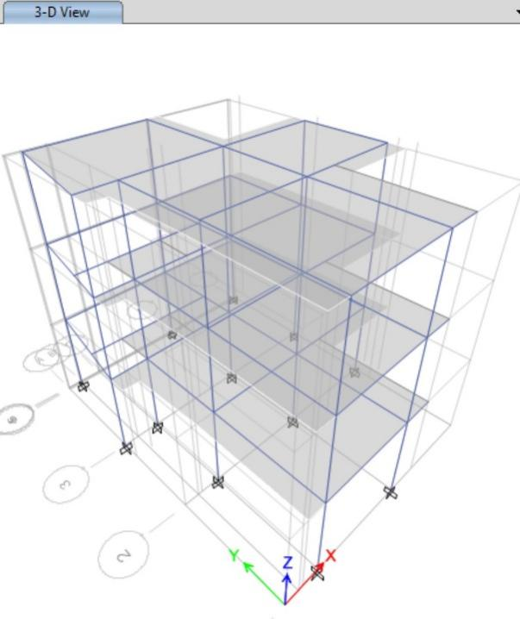

Figure 3: 3D-Model of Building

Codes and Standard used
For the structural analysis and design, the following codes and standard are followed:
- IS 456- 2000 Code of practice for plain and reinforced concrete
- IS 875-1987 Code of practice for design loads (other than earthquake) for buildings and structures
- IS 1893-2002 Criteria for Earthquake Resistant Design of Structures,
- IS 13920-1993 Code of practice for ductile detailing of reinforced concrete structures subjected to seismic forces
- NBC Nepal Building Code

Software Used
The following software is used for the structural analysis and design.
ETABS 2016 V 16.2.1 For analysis and design of the structures

For structural modeling of the present building, ETABS software was used. ETABS is a special purpose finite element analysis and design program developed specifically for building systems. With ETABS, models are defined logically floorby-floor, column-by-column, bay-by-bay and wall-by-wall and not as a stream of non-descript nodes and elements as in general purpose programs. The software has very powerful numerical methods, design procedures and international design codes, all working from a single comprehensive database. At its core, it utilizes the same analysis engine as used by SAP2000.
Among others, ETABS can do model generation, seismic and wind load generation, finite element-based linear and non-linear static and dynamic analysis, concrete frame design (column and beam) and shear wall design.

Analysis

Material properties

Concrete
Structural elements are designed for M25 grade as specified.
Modulus of Elasticity [E_{c}] = 5000 √f_{ck} N/mm² (Cl. 6.2.3.1, IS 456:2000)
= 25000 N/mm² for M25
Poisson’s Ratio [U] = 0.2
Unit Weight = 25 KN/m³
Characteristic Strength [ƒ_{ck}] = 25 N/mm² for M25
The structural design strength is derived from the characteristic strength multiplied by a coefficient 0.67 and divided by the material partial safety factor. The partial factor for concrete in flexure and axial load is 1.5.

Reinforcement Steel
Characteristic strength of high yield steel is taken as 500 MPa for main longitudinal rebar and 500 Mpa for shear rebar and material partial safety factor is to be 1.15.
Modulus of Elasticity [E_{s}] = 2x10⁵ N/mm²
Poisson’s Ratio [U] = 0.3

Section Properties
• Preliminary Size of Members
The preliminary sizes of Beam, Column, and Slab were chosen based on experience.
Beam | : 230 mm x 350 mm M25
Column | : 300 mm x 300 mm M25
Floor Slab Thickness | : 125 mm M20
Staircase Slab Thickness | : 125 mm M20
During the analysis, beam and column are modeled as frame elements whereas slabs are modeled as area element.

Loadings
The following considerations are made during the loading on the structural model:
- The loads distributed over the area are imposed on the area element and the loads distributed over the length are imposed on the frame elements whenever possible.
- Where such loading is not possible, equivalent conversion to different loading distribution is carried to load the model near the real case as far as possible.
- For lateral load, necessary calculations are performed to comply with the requirements of NBC 105: 1994.

Load Cases
The following load cases are used for the loading during analysis.

Table 1: Load Cases
Load Name | Load  Type | Description | Unit | Remarks
DL | Dead | Self-wt of the structure | kN/m²
WL | S. Dead | Wall Load | kN/m | on beam
FFL | S. Dead | Floor Finish Load | kN/m² | on slab
PWL | S. Dead | Partition Wall Load | kN/m² | on slab
LL | Live | Imposed Load | kN/m² | on slab
TLL | Live | Imposed Load | kN/m² | on terrace slab
EQ_{X} | Quake | As per NBC 105 |  | X+0.05Y
EQ_{Y} | Quake | As per NBC 105 |  | Y+0.05X

Load Combination
The following load combinations are specified as per NBC 105:1994:
Static Load Combination:
1.5(DL + LL)
Seismic Load Combination:
DL +1.3LL ±1.25 EQ_{x} / EQ_{y}
0.9 DL ±1.25 EQ_{x} / EQ_{y}
The following load combinations are used during analysis

Table 2: Load Combination
S.N | Name | Type
1 | 1.5(DL + LL) | 1.5(DL + LL)
2 | DL + 1.3LL+ 1.25EQ_{x} | DL + 1.3LL+ 1.25EQ_{x}
3 | DL + 1.3LL-1.25EQ_{x} | DL + 1.3LL- 1.25EQ_{x}
4 | DL + 1.3LL+ 1.25EQ_{y} | DL + 1.3LL+ 1.25EQ_{y}
5 | DL + 1.3LL-1.25EQ_{y} | DL + 1.3LL- 1.25EQ_{y}
6 | 0.9DL + 1.25EQ_{x} | 0.9DL + 1.25EQ_{x}
7 | 0.9DL - 1.25EQ_{x} | 0.9DL - 1.25EQ_{x}
8 | 0.9DL + 1.25EQ_{y} | 0.9DL + 1.25EQ_{y}
9 | 0.9DL - 1.25EQ_{y} | 0.9DL - 1.25EQ_{y}

MODELLING OF THE STRUCTURE
The structure is modelled in ETABS version 15, different data for modelling are shown in the following sections.

Three Dimensional views of Model
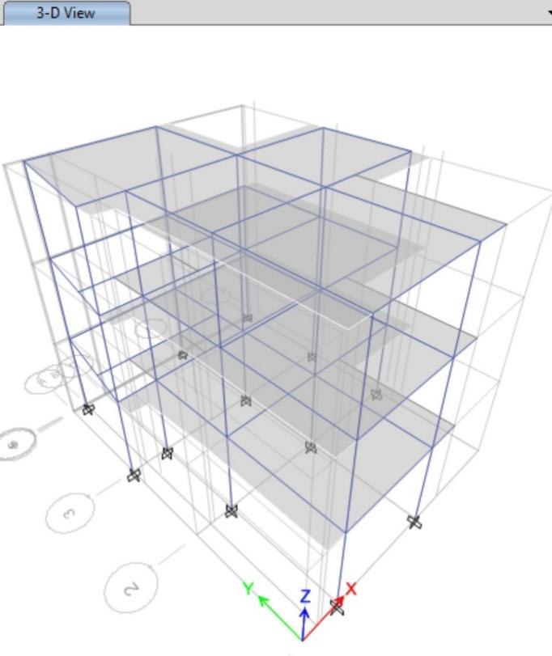

Joint ID
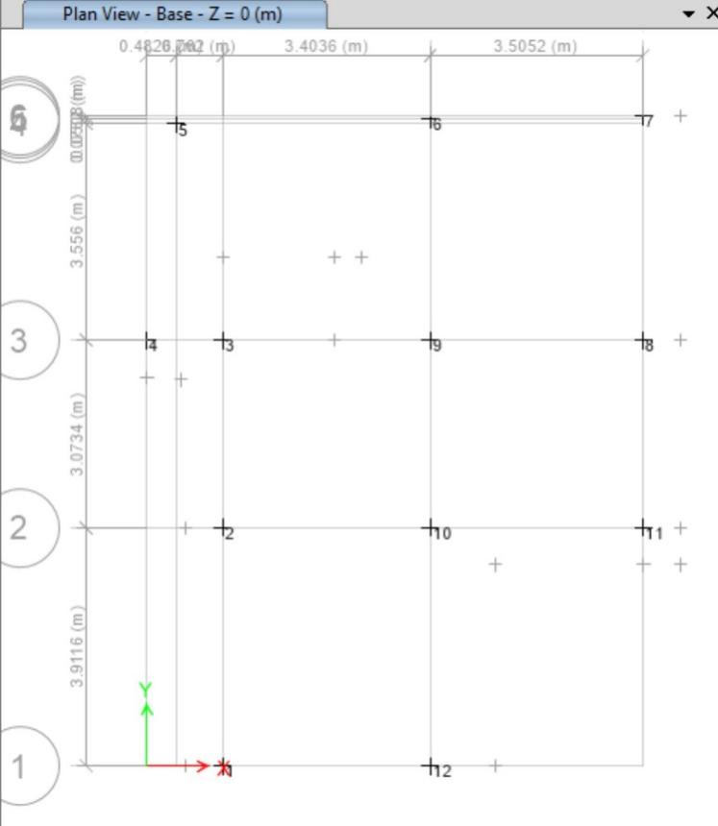

Section Property

Beam and Columns
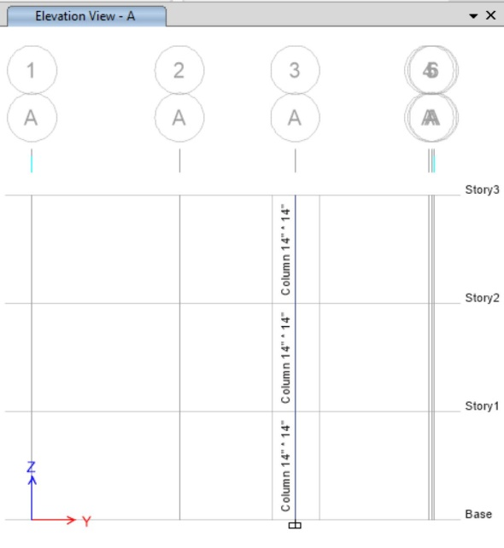
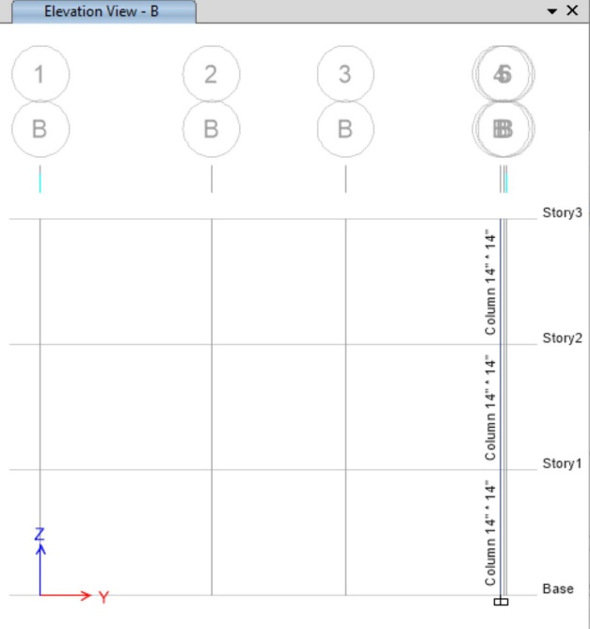
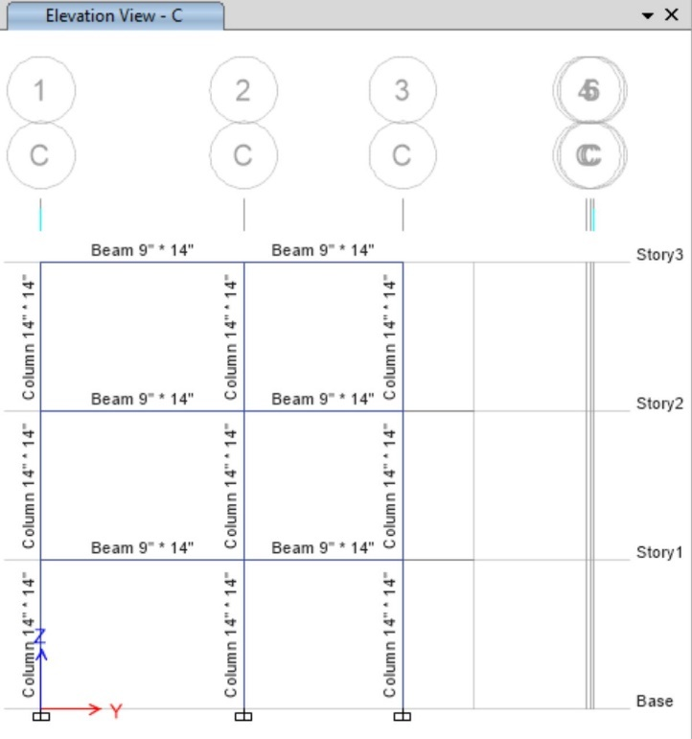
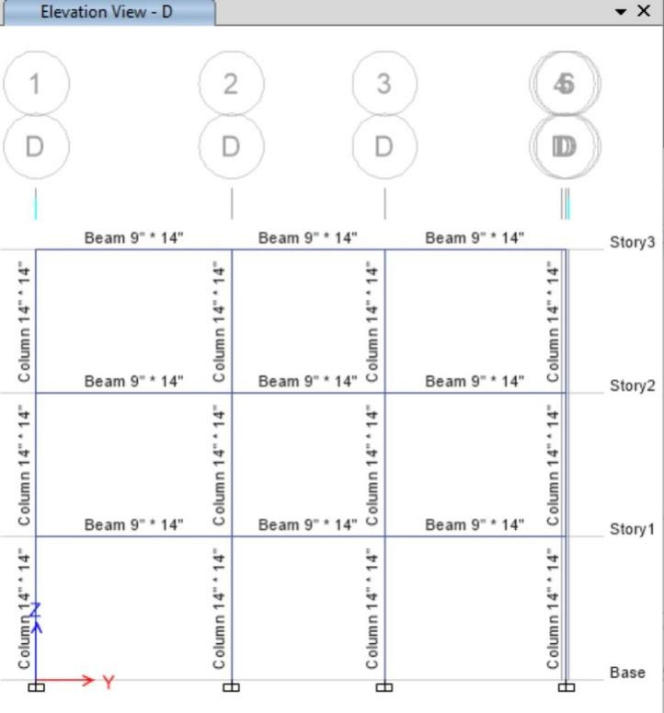
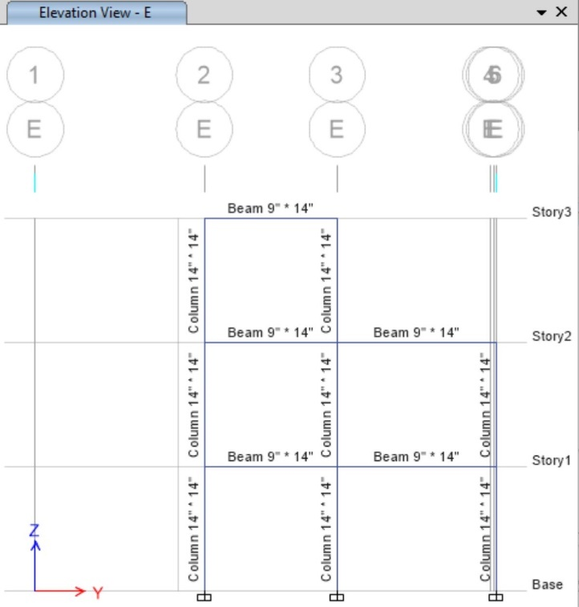

Slab
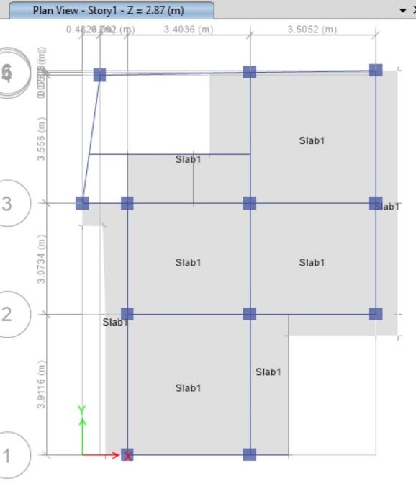

Application of loads
The loads on the building are based on Indian codes of Practices. The unit weight of different structural and non-structural elements are derived from IS 875 Part 1 and presented in Table 3. The load calculations are based on actual measured drawings. The self-weight of beams, columns and slabs are calculated by the program. Similarly the imposed loads are applied on the slab as area load in kN/m² and values of imposed loads are tabulated in Table 5 below.
- The weight of infill walls are calculated and applied on beams as line weight in kN/m.
- Partition wall load are assigned as uniformly distributed area load in slab as area load in kN/m².
- Floor finishing load are assigned as area load in slab.
- Single type of Live load is assigned in each panel of slab.
- A frame load is applied as parapet loading on the exterior frame of the roof level.
- The roof is assumed accessible and loaded with roof live load as per Indian Standard, IS 875 -1987(part2) but this load is not considered during seismic load.

Dead Loads

Unit Weight (Dead Load)
Dead loads for analysis are calculated as per Indian Standard, IS 875 -1987 (part-I). Unit weights of different material used are given below.

Table 3: Unit Weight of Materials
S.N | Type | Value
1 | Reinforced Concrete | 25 kN/m³
2 | Brick Masonry | 16.5 kN/m³
3 | Screed | 21.0 kN/m³
4 | Marble | 26.7 kN/m³
5 | Plaster | 20.4 kN/m³
7 | Steel Rebar | 78.6 KN/m³

Table 4: Dead Load Calculation

- Unit Weights of materials
Brick masonry 16.5 kN/m³
Screed 21 kN/m³
Mosaic 23.1 kN/m³
Marble 26.7 kN/m³
Reinforced Concrete 25 kN/m³ cement plaster 20.4 kN/m³
- Heights of Beams, Walls & Parapet Walls
Depth of Beam 0.350 m
Height of Building 2.845 m
Height of Parapet Wall 1.000 m Wall thickness 0.23 m

- Dead Loads of Walls
- Dead load of 230 mm thick wall 9.470 kN/m with inside and outside plaster 32.5 mm 1.671 KN/m Total 11.125 KN/m
Dead load of 230 mm thick wall with 25 % opening (Outer wall) 7.103 kN/m with inside and outside plaster 32.5 mm 1.253 KN/m Total 8.343 KN/m
Dead load of 230 mm thick wall with 15% opening (Inner wall) 8.050 kN/m with inside and outside plaster 32.5 mm 1.420 KN/m Total 9.456 KN/m
- Dead load of 115 mm thick wall 4.735 kN/m with inside and outside plaster 32.5 mm 1.671 KN/m Total 6.390 KN/m Dead load of 115 mm thick wall with 25 % opening (Outer wall) 3.551 kN/m with inside and outside plaster 32.5 mm 1.253 KN/m Total 4.792 KN/m Dead load of 115 mm thick wall with 15% opening (Inner wall) 4.025 kN/m with inside and outside plaster 32.5 mm 1.420 KN/m Total 5.431 KN/m

- Dead load of parapet wall (230 mm thick) 3.795 kN/m with inside and outside plaster 32.5 mm 0.663 KN/m Total 4.458 KN/m Dead load of parapet wall (115 mm thick) 1.898 kN/m with inside and outside plaster 32.5 mm 0.663 KN/m Total 2.561 KN/m

4 Floor Loads
Thickness of slab 0.125 m
Thickness of tile with plaster 0.025 m
Thickness of Mosaic 0.020 m
Thickness of Marble 0.020 m
Thickness of Screed 0.040 m
Thickness of Cement Plaster 0.0125 m

Dead load of structural slab 3.125 kN/m²
Dead load of Tile 0.510 kN/m²
Dead load of Mosaic 0.462 kN/m²
Dead load of Marble 0.534 kN/m²
Dead load of screed 0.840 kN/m²
Dead load of Cement Plaster 0.255 kN/m²
Total dead load of Floor Finishes (Tile) 1.350 kN/m²
Total dead load of Floor Finishes (Mosaic) 1.302 kN/m²
Total dead load of Floor Finishes (Marble) 1.374 kN/m²
Total dead load of Floor Finishes (Cement Punning) 1.095 kN/m²

Dead load of light partition walls 1.200 kN/m²

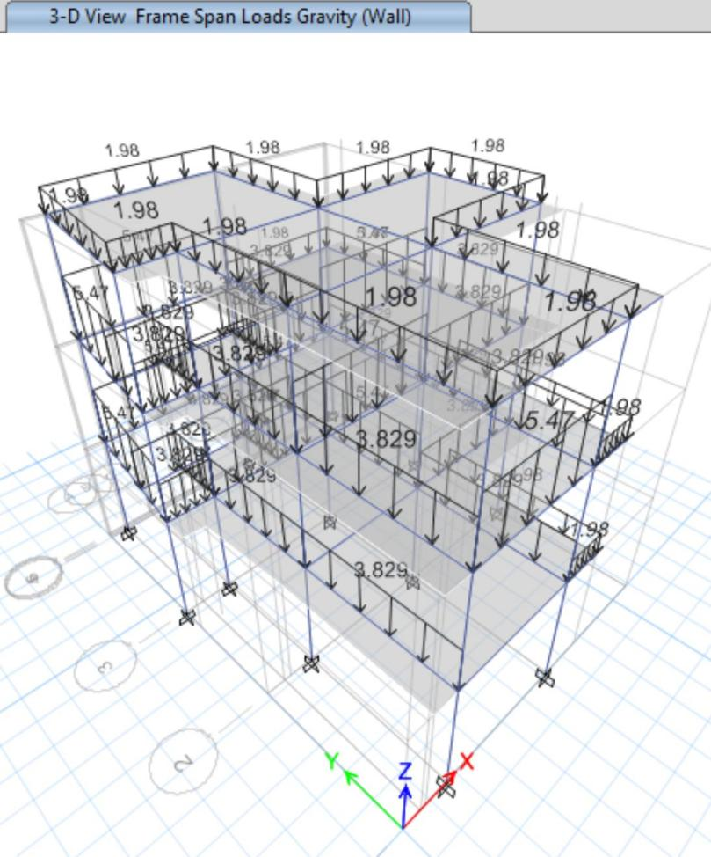

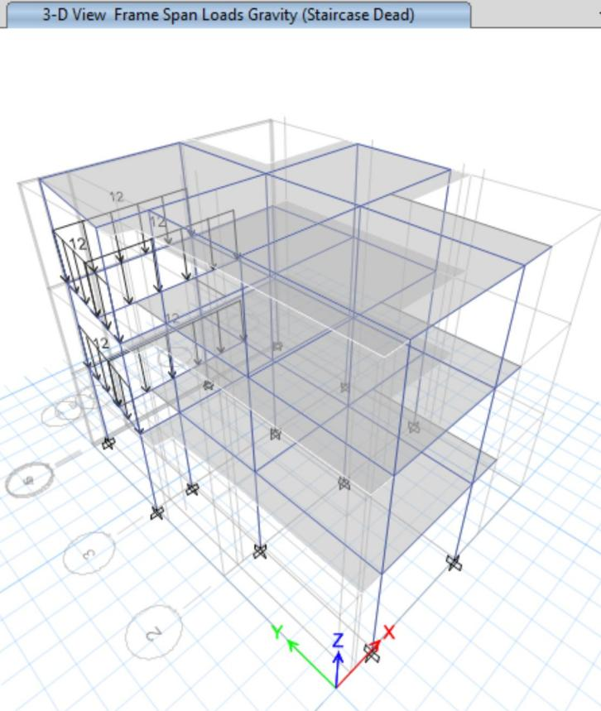

Live Load
The magnitude of live load depends upon the type of occupancy of the building. These are to be chosen from code IS875:1987(part II) for various occupancies. The live load distribution varies with time. Hence each member is designed for worst combination of dead load and live loads. Live loads for residential building are given below.

Table 5: Live Load for Residential Building
S.N | Area type | Load | Unit
1 | Rooms | 2.0 | kN/m²
2 | Terrace (Accessible) | 1.5 | kN/m²
3 | Balcony, Staircase and Passage | 3.0 | kN/m²
4 | Toilet | 2.0 | kN/m²

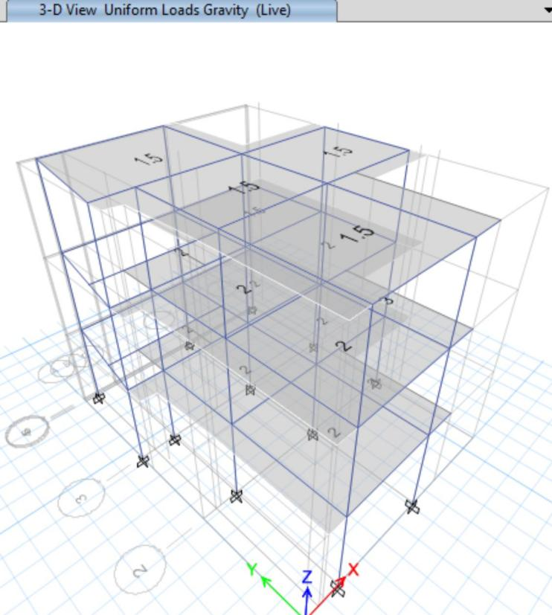

Floor Finish
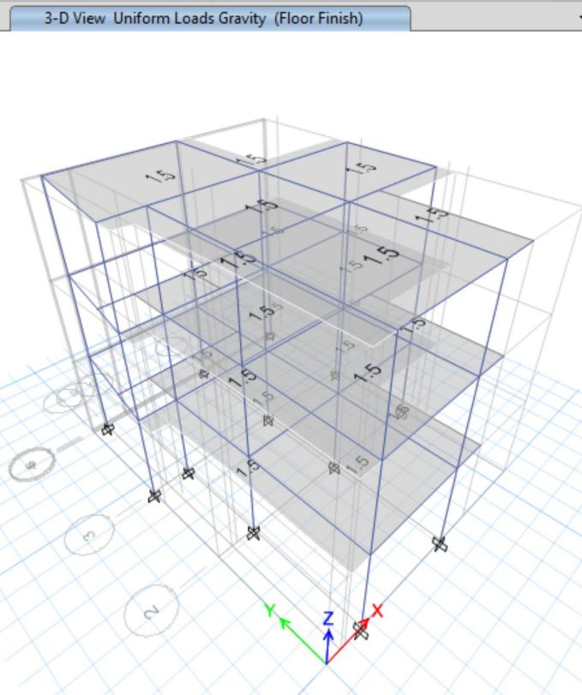

Seismic Loading
The seismic load is applied to the building with user defined coefficient in ETABS 2015 calculated as per NBC 105-1994. This load case is assumed static linear and all the necessary data and calculation are given as per the following conditions.
To determine the seismic load, it is considered that the site lies in the seismic zone Gorkha according to NBC 105. The soil type is considered as soft with 5% damping to determine average response acceleration. The building is analyzed as moment resisting frame with consideration of infill wall. Therefore the fundamental time period T_{a} is obtained by using the following formula:

Ta = 0.09ℎ/√ [Cl.7.6.2, IS 1893 -2002]
Other factors considered for seismic load calculations are as follows
Zone factor, Z = 1.0 for Kathmandu Valley [Fig. 8.2, C l 8.1.6, NBC
105:1994]
Importance factor, I = 1.0 [Table 8.1, Cl. 8.1.7, NBC 105:1994]
Structural Performance Factor, K = 1 for special RC moment resisting frame (SMRF) [Table 8.1, Cl. 8.1.8, NBC 105:1994]
Detail Calculation is presented in Table 7 below.
The seismic weight is determined based on the following mass source. [Table
6.1, Cl.6.0.0, NBC 105:1994]

Table 6: Mass Source for Seismic Load
S.N | Load Type | Scale Factor
1 | Dead Load | 1
2 | Live Load | 0.25
3 | Roof Live Load | Nil

A Report on Structural Analysis & Design of Residential Building at Mahalaxmi Municipality-09, Lamatar, Lalitpur

------------------------------------------------------------------------------------------------------------------------------------------------------------------------------

Table 7: Design Horizontal Seismic Coefficient as per NBC-105-1994
Seismic zone |  |  | Kathmandu Valley
Seismic Zone factor | Z | Cl. 8.1.6, fig 8.2 | 1
Type of Building |  |  | Residential Building
Importance factor | I | Cl.8.1.7, table 8.1 | 1.0
Lateral load resisting system |  |  | Ductile Moment Resisting Frame
Structural performance factor | K | Cl. 8.1.8, table 8.2 | 1.0
Height of the building | h |  | 11.370 | m
Dimension of the building Along X | D_{x} |  | 13.106 | m
Dimension of the building Along Y | D_{y} |  | 8.229 | m
Time period of the building along X, | T_{x}=0.09h/√D_{x} | Cl. 7.3 | 0.283 | sec
Time period of the building along Y | T_{y}=0.09h/√D_{y} | Cl. 7.3 | 0.357 | sec
Soil type |  |  | Type III (Soft Soil)
Basic seismic coefficient along X | C_{x} | Cl. 8.1.4, fig 8.1 | 0.07
Basic seismic coefficient along Y | C_{y} | Cl. 8.1.4, fig 8.1 | 0.07
Design Horizontal Seismic Coefficient along X | C_{dx} = CZIK | Cl. 8.1.1 | 0.07
Design Horizontal Seismic Coefficient along Y | C_{dy} = CZIK | Cl. 8.1.1 | 0.07

Page | 16

Analysis Output
The analysis results are discussed in this chapter. Seismic coefficient method is used. The major discussion are focused on the eccentricity, story shear, inter story drift, maximum displacement and base shear along two orthogonal directions. The column and beam size and reinforcement are then designed for maximum forces.

Seismic Coefficient Method
The fundamental time period of the building as per NBC 105:1994, clause 7.3
(b), total seismic weight and base shear in both orthogonal directions are given in Table 8 and Table 9 .

Table 8: Fundamental Time period
Direction | Time period (sec)
X | 0.283
Y | 0.357

Based on program/software calculated seismic coefficient, base shear and storey shear are as shown in the Table 9 and Table 10. To calculate these parameters, the following equation has been used as per code.
The coefficient is given by,
= CZIK = 0.07 ∗ 1 ∗ 1 ∗ 1 = 0.07
And, base shear is given by,
=

Table 9: Seismic coefficient and base shear
Seismic Weight (kN) | 3033.14
Direction | X | Y
Seismic Coefficient | 0.07 | 0.07
V_{b} (kN) | 319.41 | 319.4

Table 10: Distribution of Story forces
Story | Elevation | Storey Shear (X dir’n) | Storey Shear (Y dir’n)
 | m | kN | kN
3F | 8.534 | 115.95 | 115.95
2F | 5.689 | 138.5 | 138.5
1F | 2.844 | 64.95 | 64.95
0F | 0.000 | 0.000 | 0.000

As per cl. no. 9.3 of NBC 105:1994, the ratio of the inter storey deflection to the corresponding storey height shall not exceed 0.010 nor shall the inter storey deflection exceed 60mm. In this building the storey drift is limited to 28.44 mm. From the analysis the displacements of the mass centre of various floors are obtained and are shown in Table 11 along with storey drift.

Table 11: Storey Drift Calculations
Storey | Elevation | Storey Displacement (mm) |  | Storey drift ()
 | m | X Dir’n | Y Dir’n | X Dir’n | Y Dir’n
3F | 8.61 | 17.446 | 18.381 | 0.1619 | 0.1656
2F | 5.74 | 12.798 | 13.629 | 0.2544 | 0.271
1F | 2.87 | 5.498 | 5.85 | 0.1916 | 0.2038
0F | 0.000 | 0.000 | 0.000 | 0.000 | 0.000

It is seen that drift does not exceed the code prescribed value of 0.010 times story height (i.e. permissible storey displacement is 28.44 mm). Thus the drift check seems to comply with the safety value mentioned in the code.

Modal time period and mass participation
NBC 105:1994 clause 11.2 states that a sufficient number of modes shall be considered to ensure that at least 90 percent of the mass is participating in the direction under consideration. Analysis was carried out for first 10 modes so that the mass participation satisfies this criterion in both orthogonal directions. Table shows time period and mass participation ratio for all modes.

Story Mass over Average Displacement

ANALYSIS OF THE STRUCTURE
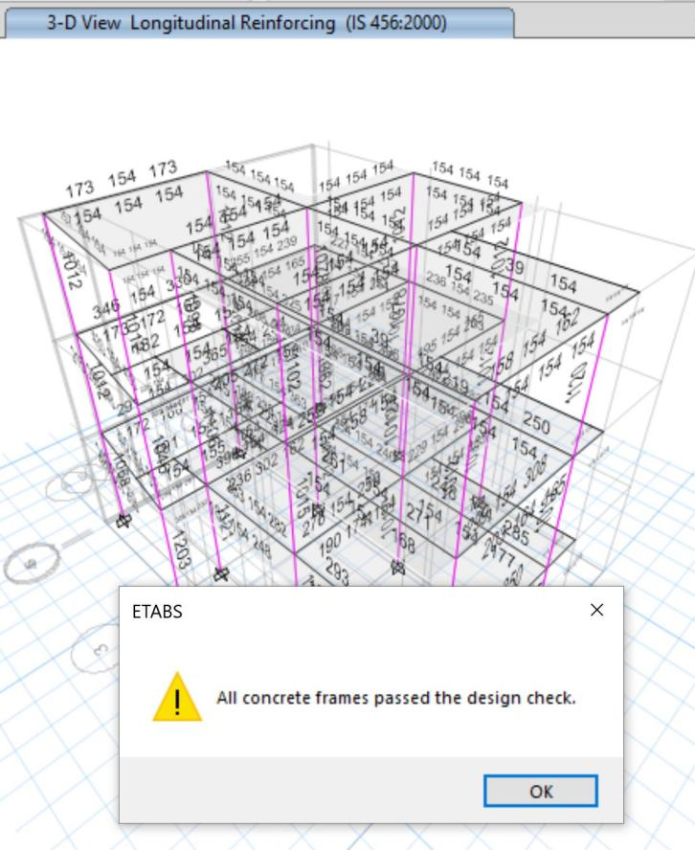

Axial Force Diagram
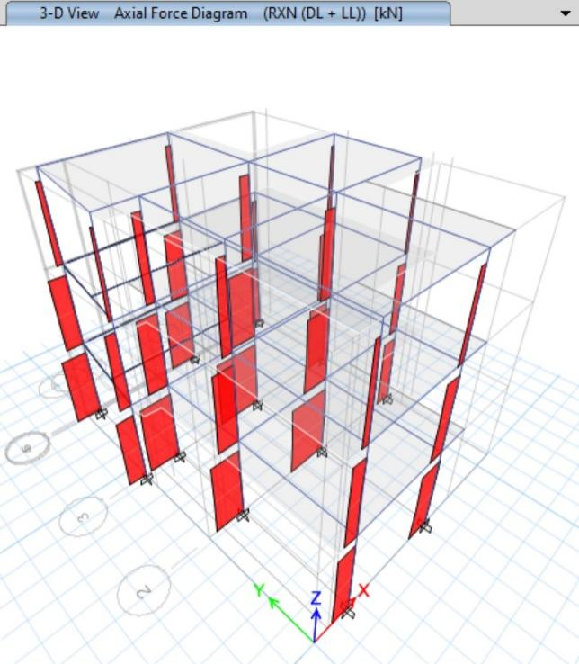

Shear Force Diagram
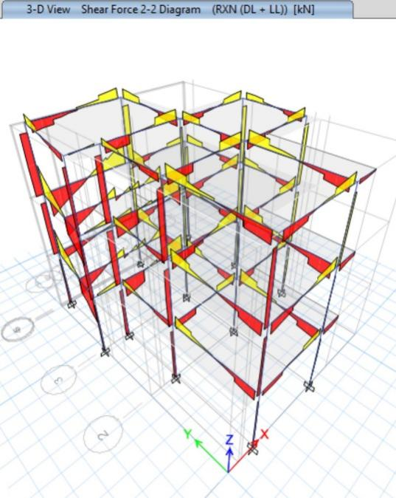

Bending Moment Diagram
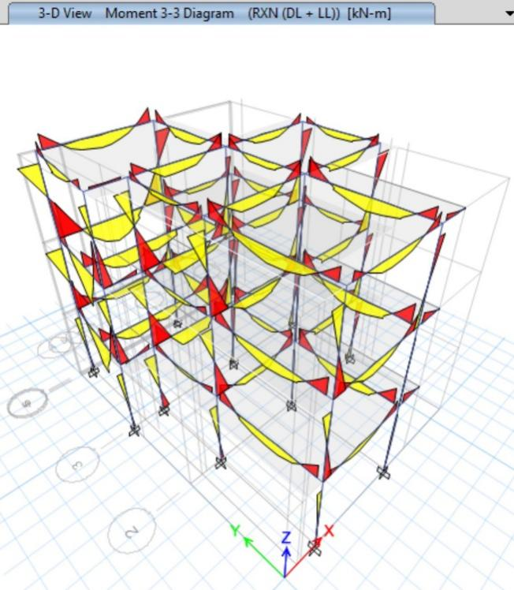

Reinforcement from Etabs

Columns
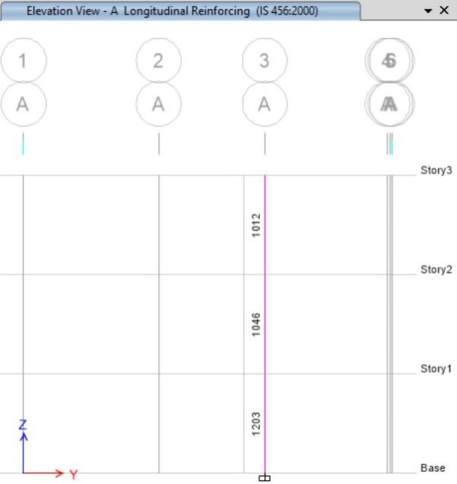 | 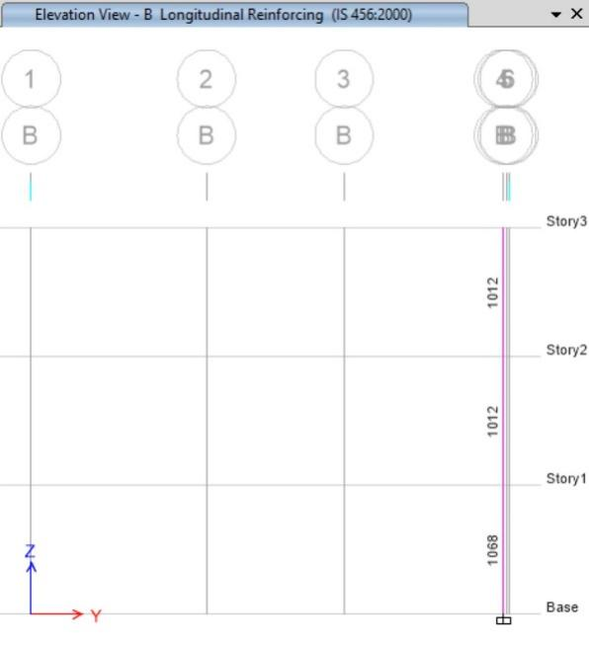
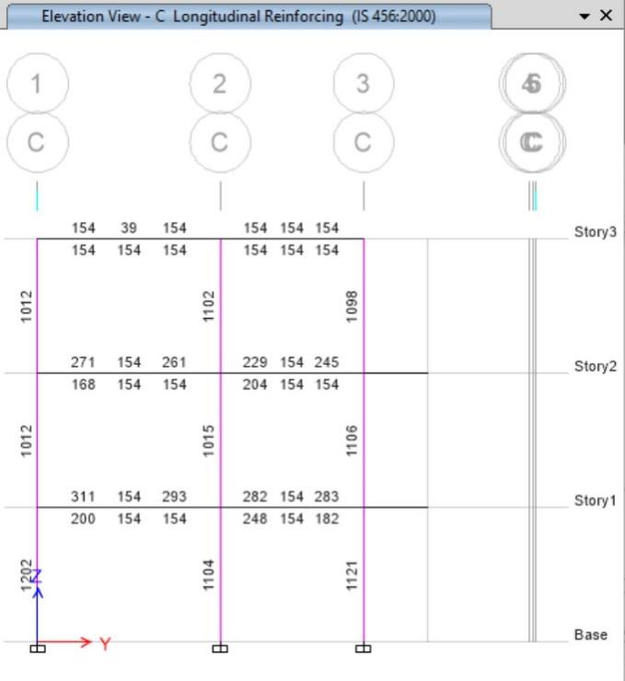 | 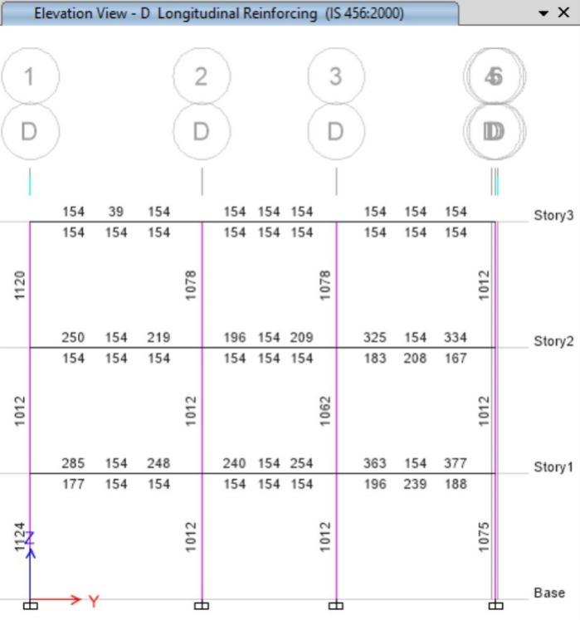
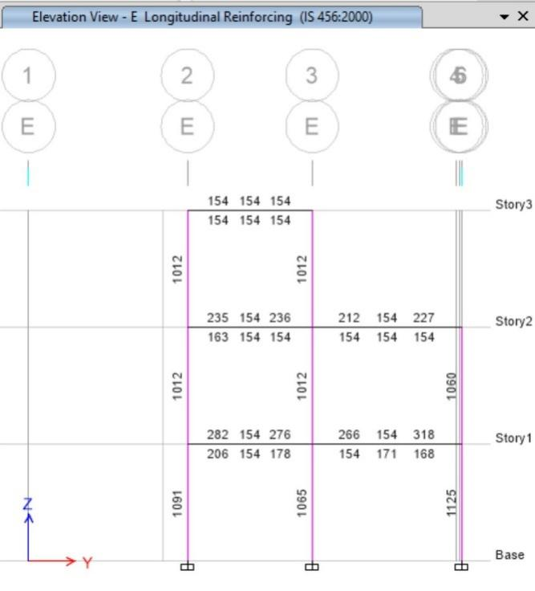

Beams
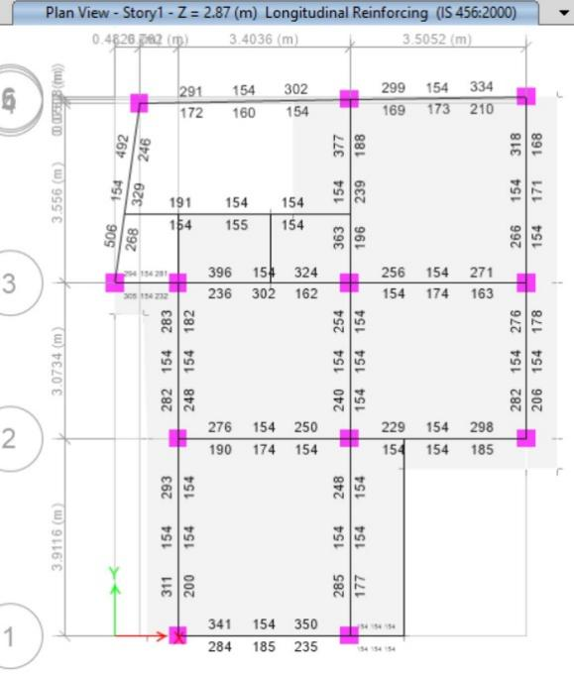

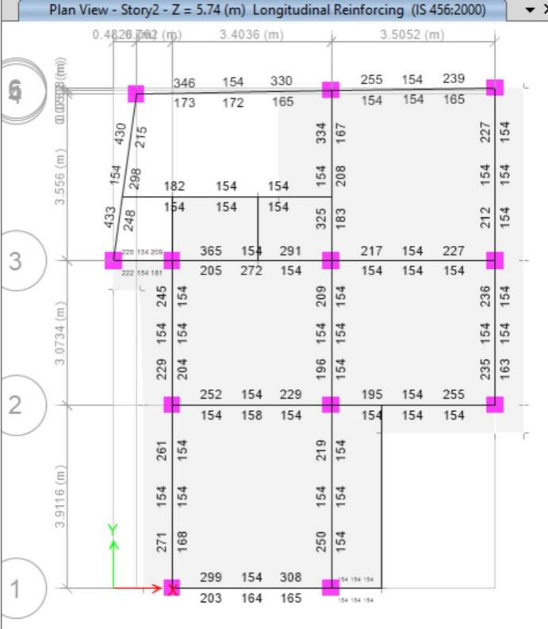
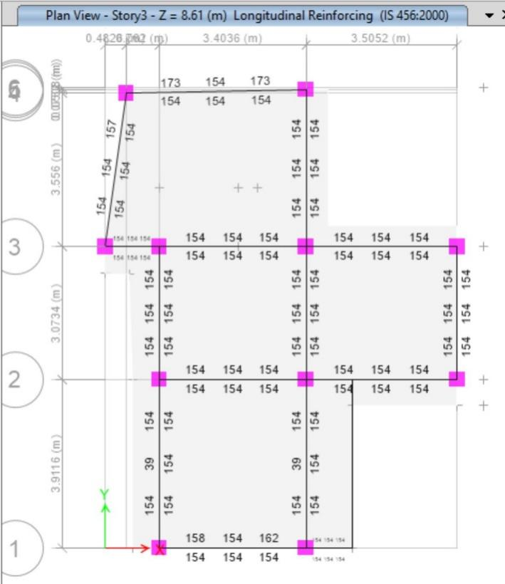

Beam Column Ratio

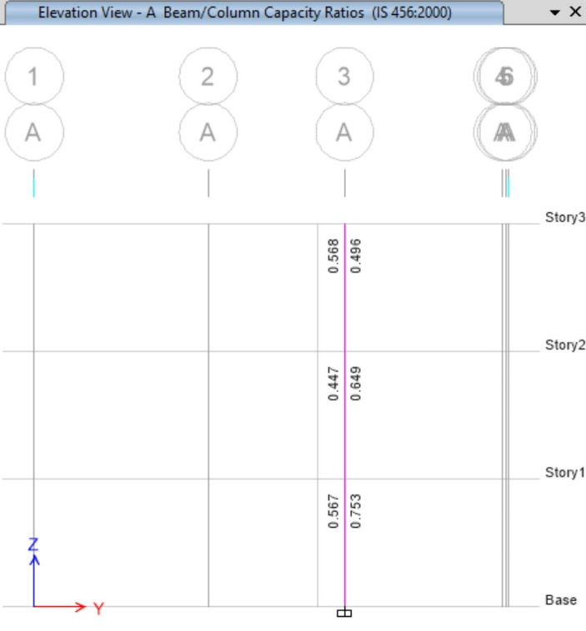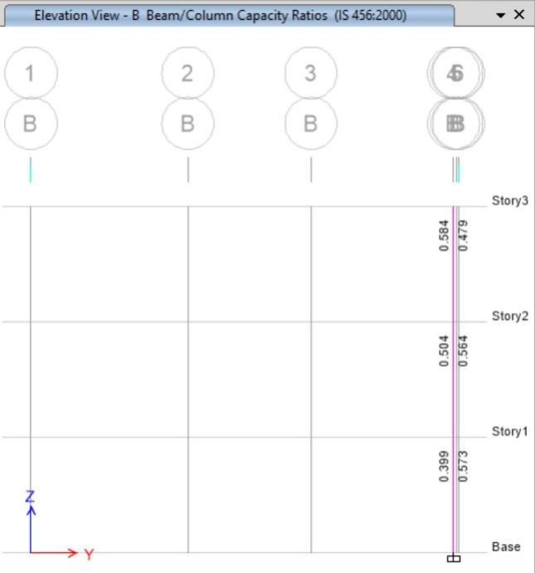
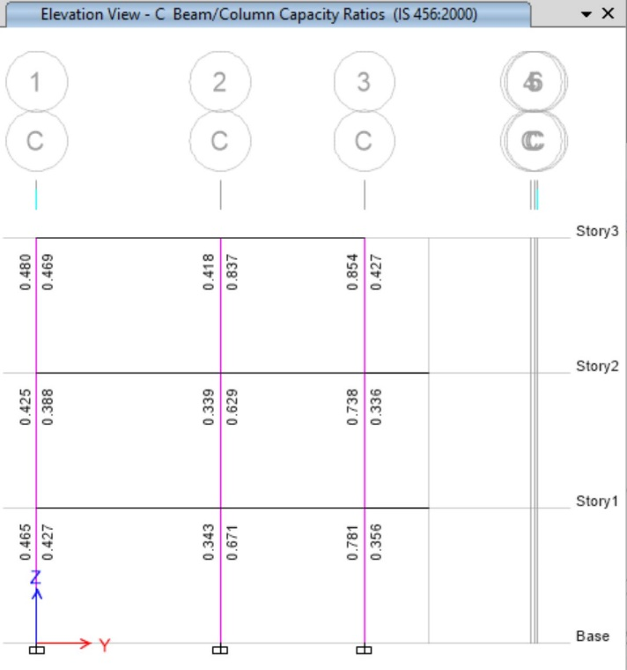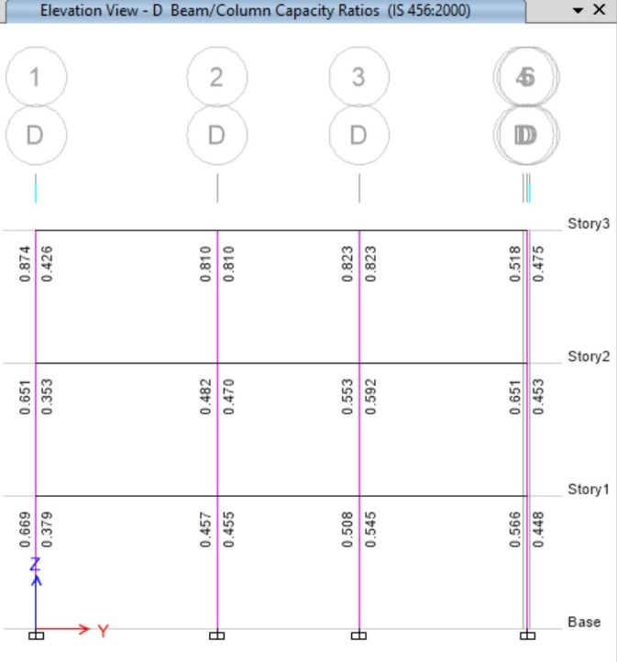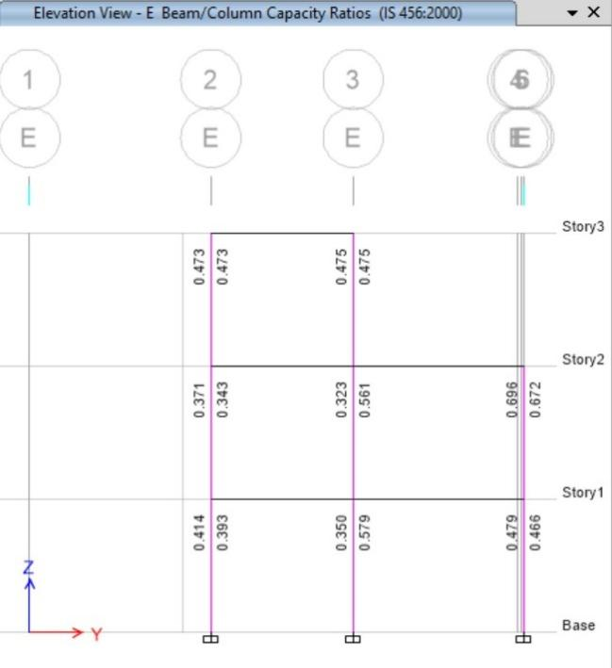

DESIGN OF STRUCTURAL ELEMENTS

Design of columns
ETABS Concrete Frame Design
IS 456:2000 + IS 13920:2016 Column Section Design

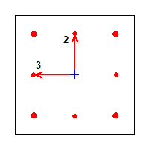

Column Element Details Type: Ductile Frame (Summary)
Level | Element | Unique Name | Section ID | Combo ID | Station Loc | Length (mm) | LLRF
Story1 | C1 | 8 | Column 14" * 14" | DL + ?LL - EQx -0.3EQy | 0 | 2870 | 0.766

Section Properties
b (mm) | h (mm) | dc (mm) | Cover (Torsion) (mm)
355.6 | 355.6 | 56 | 30

Material Properties
E_{c} (MPa) | f_{ck} (MPa) | Lt.Wt Factor (Unitless) | f_{y} (MPa) | f_{ys} (MPa)
22360.68 | 20 | 1 | 500 | 500

Design Code Parameters
ɣ_{C} | ɣ_{S}
1.5 | 1.15

Axial Force and Biaxial Moment Design For P_{u} , M_{u2} , M_{u3}
Design P_{u}  kN | Design M_{u2}  kN-m | Design M_{u3}  kN-m | Minimum M₂  kN-m | Minimum M₃  kN-m | Rebar Area  mm² | Rebar %  %
450.5076 | -35.8497 | -97.8976 | 9.0102 | 9.0102 | 1921 | 1.52

Axial Force and Biaxial Moment Factors
 | K Factor  Unitless | Length  mm | Initial Moment  kN-m | Additional Moment  kN-m | Minimum Moment  kN-m
Major Bend(M3) | 0.786808 | 2438.2 | -48.5764 | 0 | 9.0102
Minor Bend(M2) | 0.787383 | 2438.2 | -22.1994 | 0 | 9.0102

Shear Design for V_{u2} , V_{u3}
 | Shear V_{u}  kN | Shear V_{c}  kN | Shear V_{s}  kN | Shear V_{p}  kN | Rebar A_{sv} /s  mm²/m
Major, V_{u2} | 58.0066 | 95.2984 | 42.6146 | 58.0066 | 394.16
Minor, V_{u3} | 46.2235 | 95.2984 | 42.6146 | 46.2235 | 394.16

Joint Shear Check/Design
 | Joint Shear  Force  kN | Shear  V_{Top}  kN | Shear  V_{u,Tot}  kN | Shear  V_{c}  kN | Joint  Area  cm² | Shear  Ratio  Unitless
Major Shear, V_{u2} | N/A | N/A | N/A | N/A | N/A | N/A
Minor Shear, V_{u3} | N/A | N/A | N/A | N/A | N/A | N/A

(1.4) Beam/Column Capacity Ratio
Major Ratio | Minor Ratio
N/A | N/A

Additional Moment Reduction Factor k (IS 39.7.1.1)
A_{g}  cm² | A_{sc}  cm² | P_{uz}  kN | P_{b}  kN | P_{u}  kN | k  Unitless
1264.5 | 19.2 | 1858.325 | 468.2342 | 450.5076 | 1

Additional Moment (IS 39.7.1)
 | Consider  M_{a} | Length  Factor | Section  Depth (mm) | KL/Depth  Ratio | KL/Depth  Limit | KL/Depth  Exceeded | M_{a}  Moment (kN-m)
Major Bending (M₃ ) | Yes | 0.85 | 355.6 | 5.395 | 12 | No | 0
Minor Bending (M₂ ) | Yes | 0.85 | 355.6 | 5.399 | 12 | No | 0

Notes:
N/A: Not Applicable
N/C: Not Calculated
N/N: Not Needed

Table 1: Summary of Design of Column
S.N. | Grid Location | Column Size | Ground Floor | First Floor | Second Floor& Third Floor | Stirrups
1 | A3 | 350 x 350 | 4-16Ø 4-12Ø | 4-16Ø 4-12Ø | 4-16Ø 4-12Ø | mm C/C (at top and bottom) & @ 150 mm C/C (at mid height) in all columns
2 | B4 | 350 x 350 | 4-16Ø 4-12Ø | 4-16Ø 4-12Ø | 4-16Ø 4-12Ø
3 | C1 | 350 x 350 | 4-16Ø 4-12Ø | 4-16Ø 4-12Ø | 4-16Ø 4-12Ø
4 | C2 | 350 x 350 | 4-16Ø 4-12Ø | 4-16Ø 4-12Ø | 4-16Ø 4-12Ø
5 | C3 | 350 x 350 | 4-16Ø 4-12Ø | 4-16Ø 4-12Ø | 4-16Ø 4-12Ø
6 | D1 | 350 x 350 | 4-16Ø 4-12Ø | 4-16Ø 4-12Ø | 4-16Ø 4-12Ø
7 | D2 | 350 x 350 | 4-16Ø 4-12Ø | 4-16Ø 4-12Ø | 4-16Ø 4-12Ø
8 | D3 | 350 x 350 | 4-16Ø 4-12Ø | 4-16Ø 4-12Ø | 4-16Ø 4-12Ø
9 | D5 | 350 x 350 | 4-16Ø 4-12Ø | 4-16Ø 4-12Ø | 4-16Ø 4-12Ø
10 | E2 | 350 x 350 | 4-16Ø 4-12Ø | 4-16Ø 4-12Ø | 4-16Ø 4-12Ø
11 | E3 | 350 x 350 | 4-16Ø 4-12Ø | 4-16Ø 4-12Ø | 4-16Ø 4-12Ø
12 | E6 | 350 x 350 | 4-16Ø 4-12Ø | 4-16Ø 4-12Ø | 4-16Ø 4-12Ø

DESIGN OF BEAMS
ETABS Concrete Frame Design
IS 456:2000 + IS 13920:2016 Beam Section Design

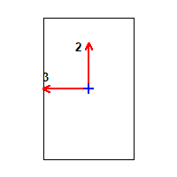

Beam Element Details Type: Ductile Frame (Summary) (Part 1 of 2)
Level | Element | Unique Name | Section ID | Combo ID | Station Loc
Story1 | B9 | 76 | Beam 9" * 14" | DL + ?LL - 0.3EQx - EQy | 177.8

Beam Element Details Type: Ductile Frame (Summary) (Part 2 of 2)
Length (mm) | LLRF
4597.4 | 1

Section Properties
b (mm) | h (mm) | b_{f} (mm) | d_{s} (mm) | d_{ct} (mm) | d_{cb} (mm)
228.6 | 355.6 | 228.6 | 0 | 41 | 41

Material Properties
E_{c} (MPa) | f_{ck} (MPa) | Lt.Wt Factor (Unitless) | f_{y} (MPa) | f_{ys} (MPa)
22360.68 | 20 | 1 | 500 | 500

Design Code Parameters
ɣ_{C} | ɣ_{S}
1.5 | 1.15

Factored Forces and Moments
Factored  M_{u3}  kN-m | Factored  T_{u}  kN-m | Factored  V_{u2}  kN | Factored  P_{u}  kN
-58.2159 | 1.6389 | 61.4473 | 0.0135

Design Moments, M_{u3} & M_{t}
Factored  Moment  kN-m | Factored  M_{t}  kN-m | Positive  Moment  kN-m | Negative  Moment  kN-m
-58.2159 | 2.4638 | 0 | -60.6796

Design Moment and Flexural Reinforcement for Moment, M_{u3} & T_{u}
 | Design  -Moment  kN-m | Design  +Moment  kN-m | -Moment  Rebar  mm² | +Moment  Rebar  mm² | Minimum  Rebar  mm² | Required  Rebar  mm²
Top (+2 Axis) | -60.6796 |  | 503 | 0 | 503 | 154
Bottom (-2 Axis) |  | 0 | 252 | 0 | 0 | 252

Shear Force and Reinforcement for Shear, V_{u2} & T_{u}
Shear V_{e}  kN | Shear V_{c}  kN | Shear V_{s}  kN | Shear V_{p}  kN | Rebar A_{sv} /s  mm²/m
68.607 | 0 | 80.0781 | 28.6323 | 705.35

Torsion Force and Torsion Reinforcement for Torsion, T_{u} & V_{U2}
T_{u}  kN-m | V_{u}  kN | Core b₁  mm | Core d₁  mm | Rebar A_{svt} /s  mm²/m
1.6389 | 61.4473 | 166.6 | 293.6 | 324.83

Table 2: Beam reinforcement details
Beam Reinforcement Detail
S.N. | Type of beam | Size of beam | Direction | Reinforcement
 |  |  |  | At support |  | At center
 |  |  |  | Top | Bottom | Top | Bottom
1 | Tie beam | 230*230 | X-dir | 3-12ɸ R | 3-12ɸR | 3-12ɸR | 3-12ɸR
1 | Tie beam | 230*230 | Y-dir | 3-12ɸ R | 3-12ɸR | 3-12ɸR | 3-12ɸR
2 | Main beam First Floor,  Second, Floor | 230*430 | X-dir | 2-12ɸ R+  1-16(Ex) | 2-12ɸ R+  1-16(Ex) | 2-12ɸR | 2-12ɸR
2 | Main beam First Floor,  Second, Floor | 230*430 | Y-dir | 2-12ɸ R+  1-16(Ex) | 2-12ɸ R+  1-16(Ex) | 2-12ɸ R | 2-12ɸR
3 | Main beam Top Floor | 230*430 | X-dir | 2-12ɸ R+  1-16(Ex) | 2-12ɸ R+  1-16(Ex) | 2-12ɸR | 2-12ɸR
 |  |  | Y-dir | 2-12ɸ R+  1-16(Ex) | 2-12ɸ R+  1-16(Ex) | 2-12ɸR | 2-12ɸR

DESIGN OF SLAB

DESIGN OF STAIRCASE
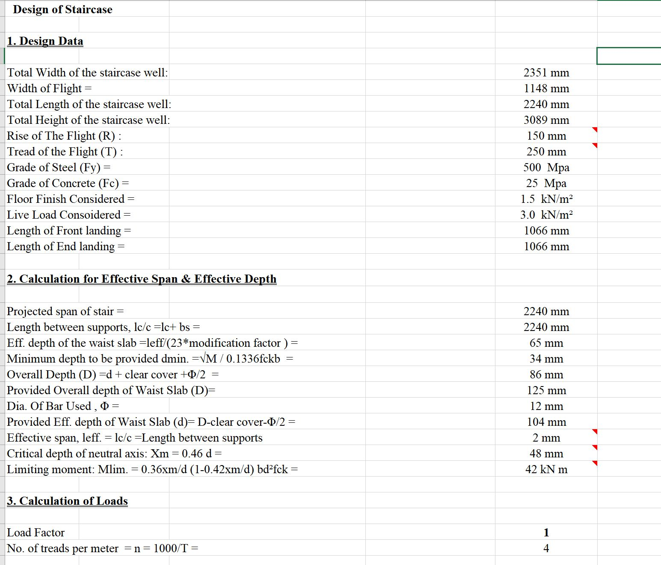

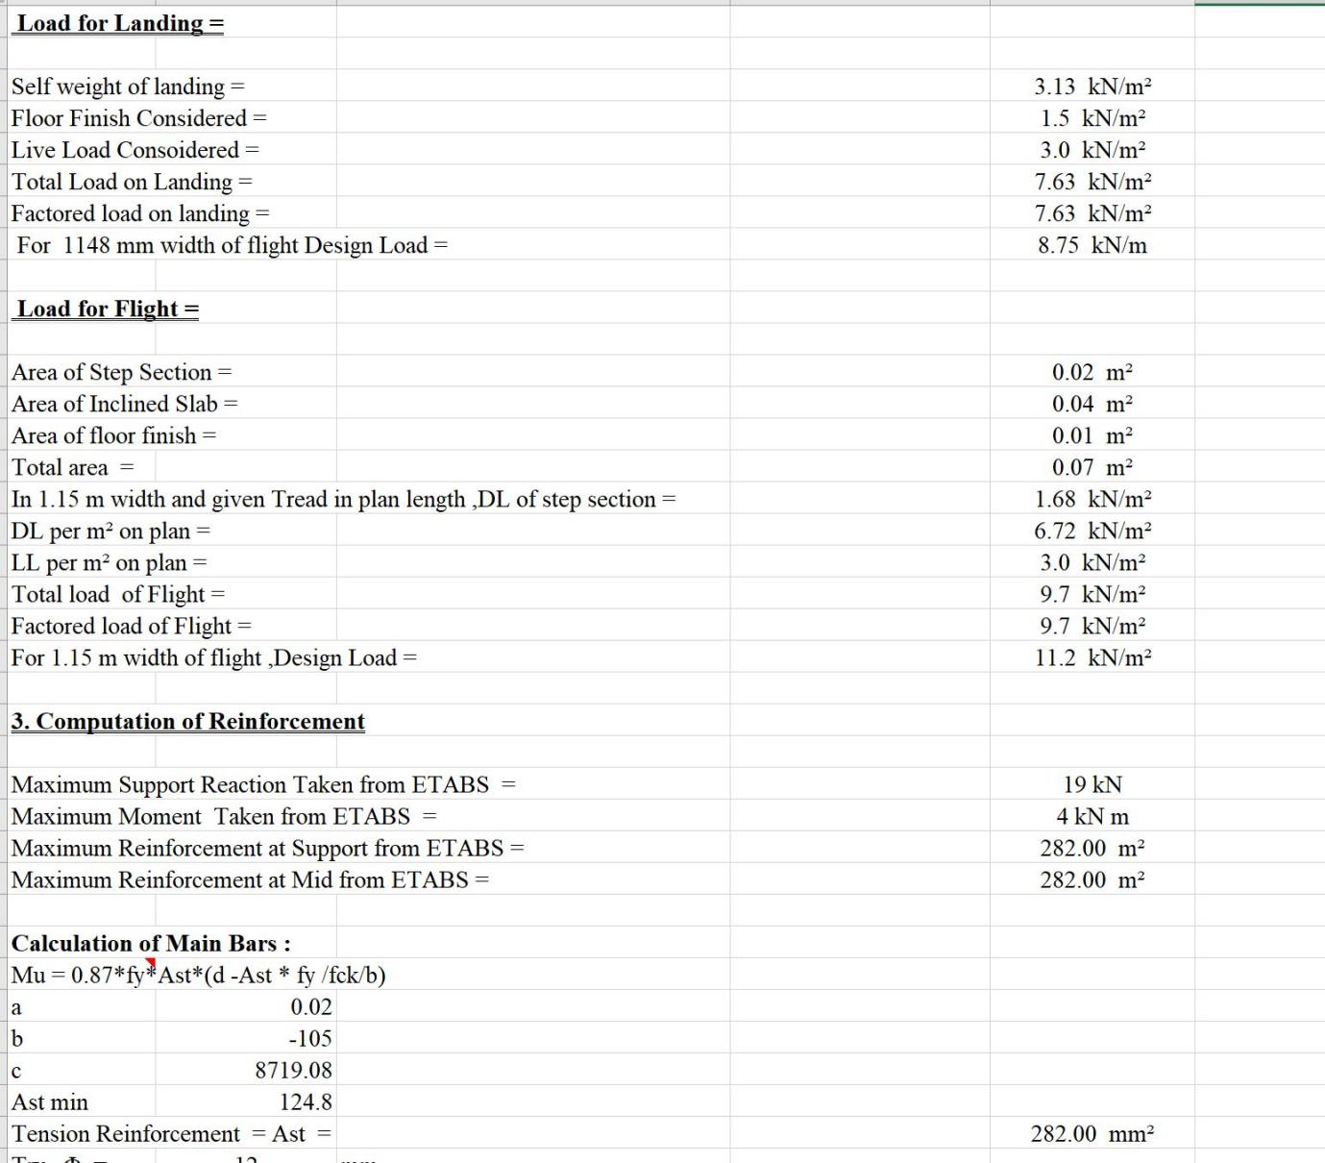

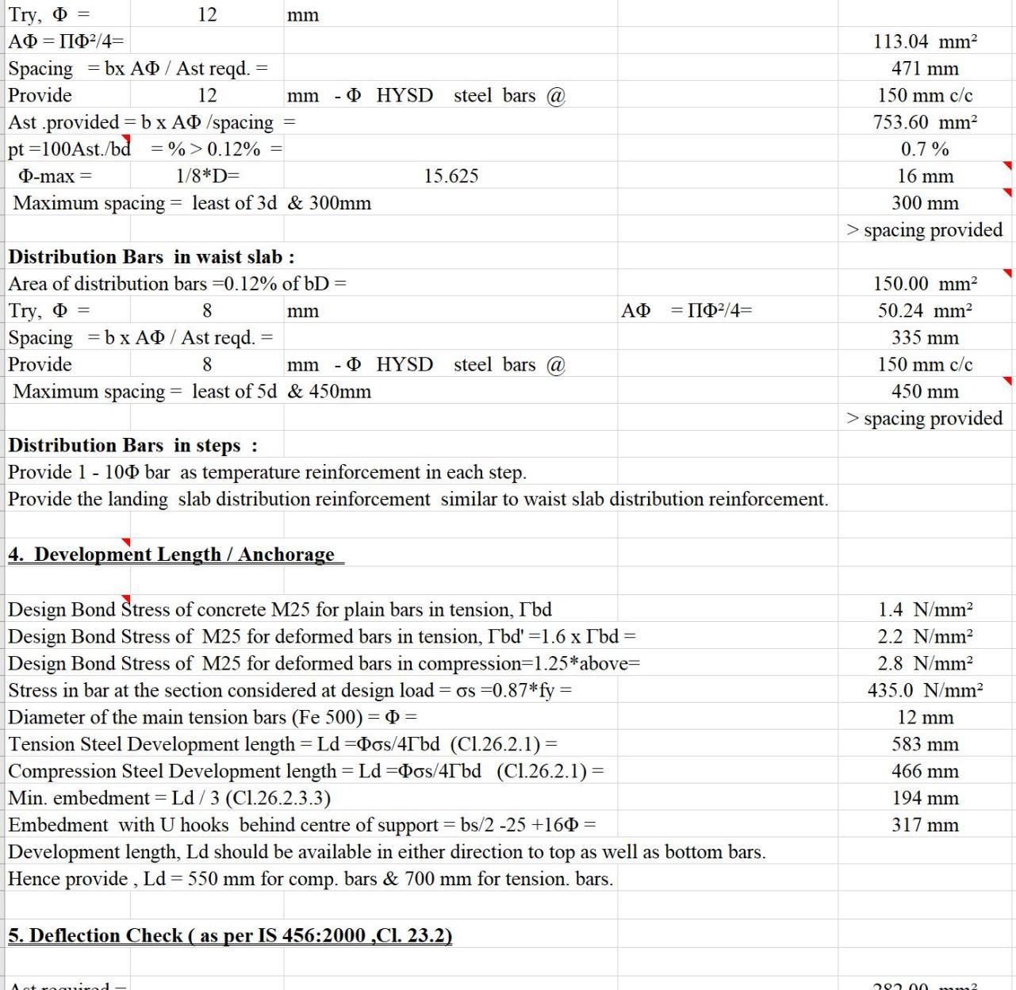
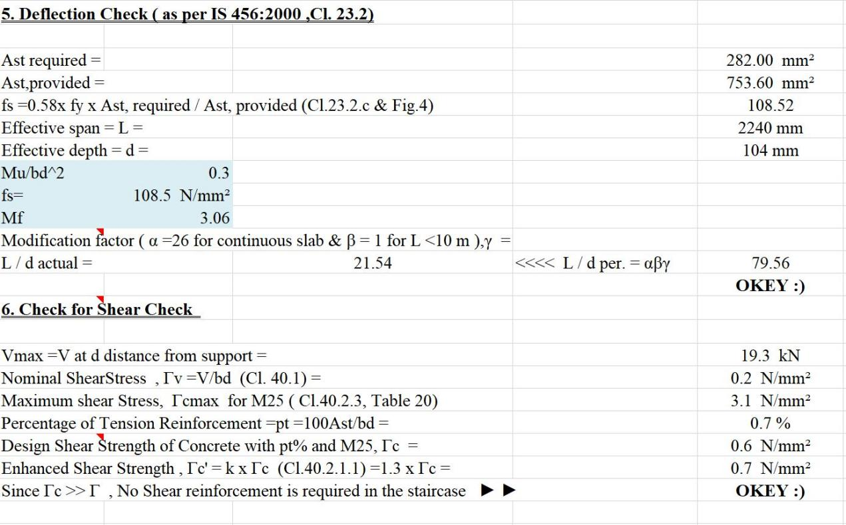

  - Design of Footing
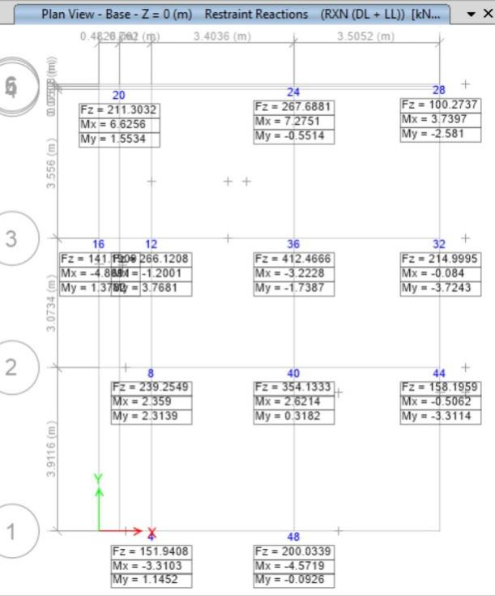

- Isolated, Strap and Combined Footing is designed
- Soil Subgrade Modulus
Factor of saftely : 3
Soil bearing Capacity : 120 KN/m2
Allowable Settlement : 25 mm
Soil Spring Modulus = 3 x 150 x (1000/20)
= 225000 KN/m3
Preliminary slab thickness = 457.2 mm (18”)

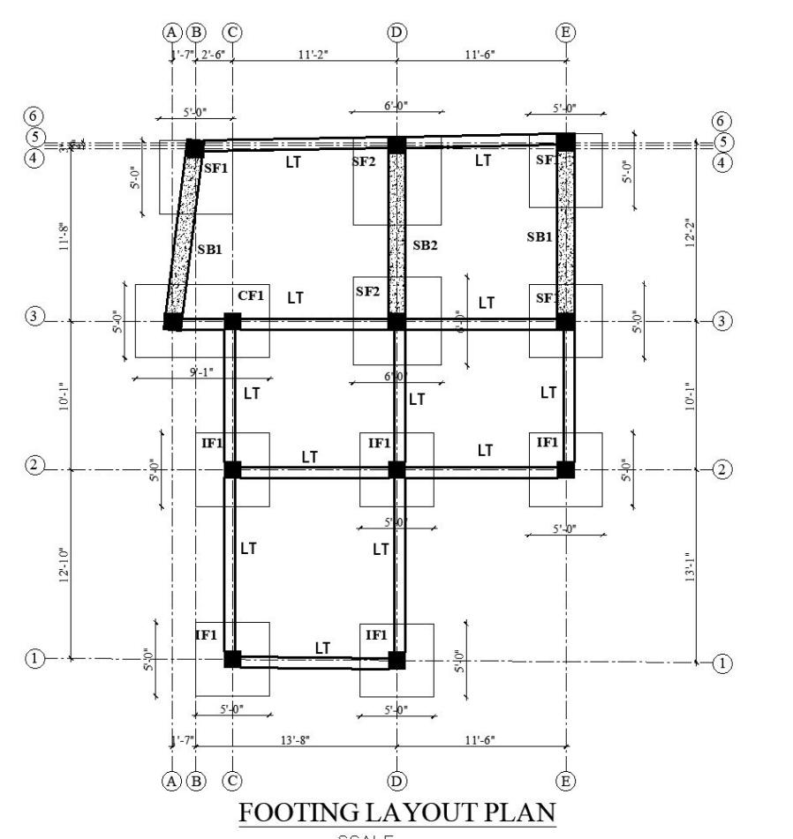
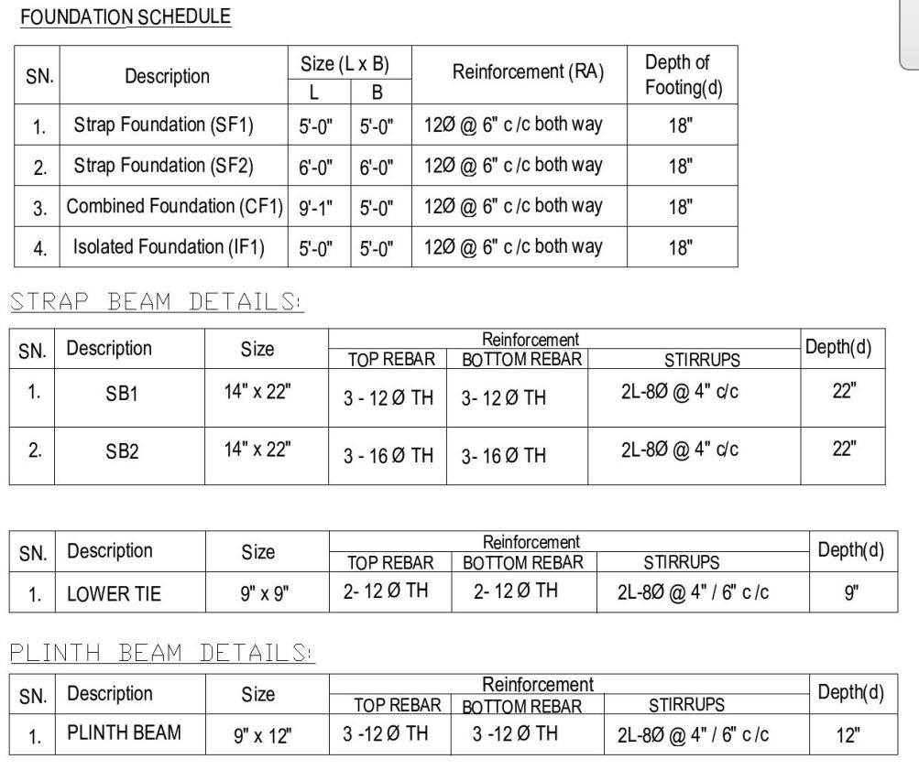

Design of beam manual
For Top Bar
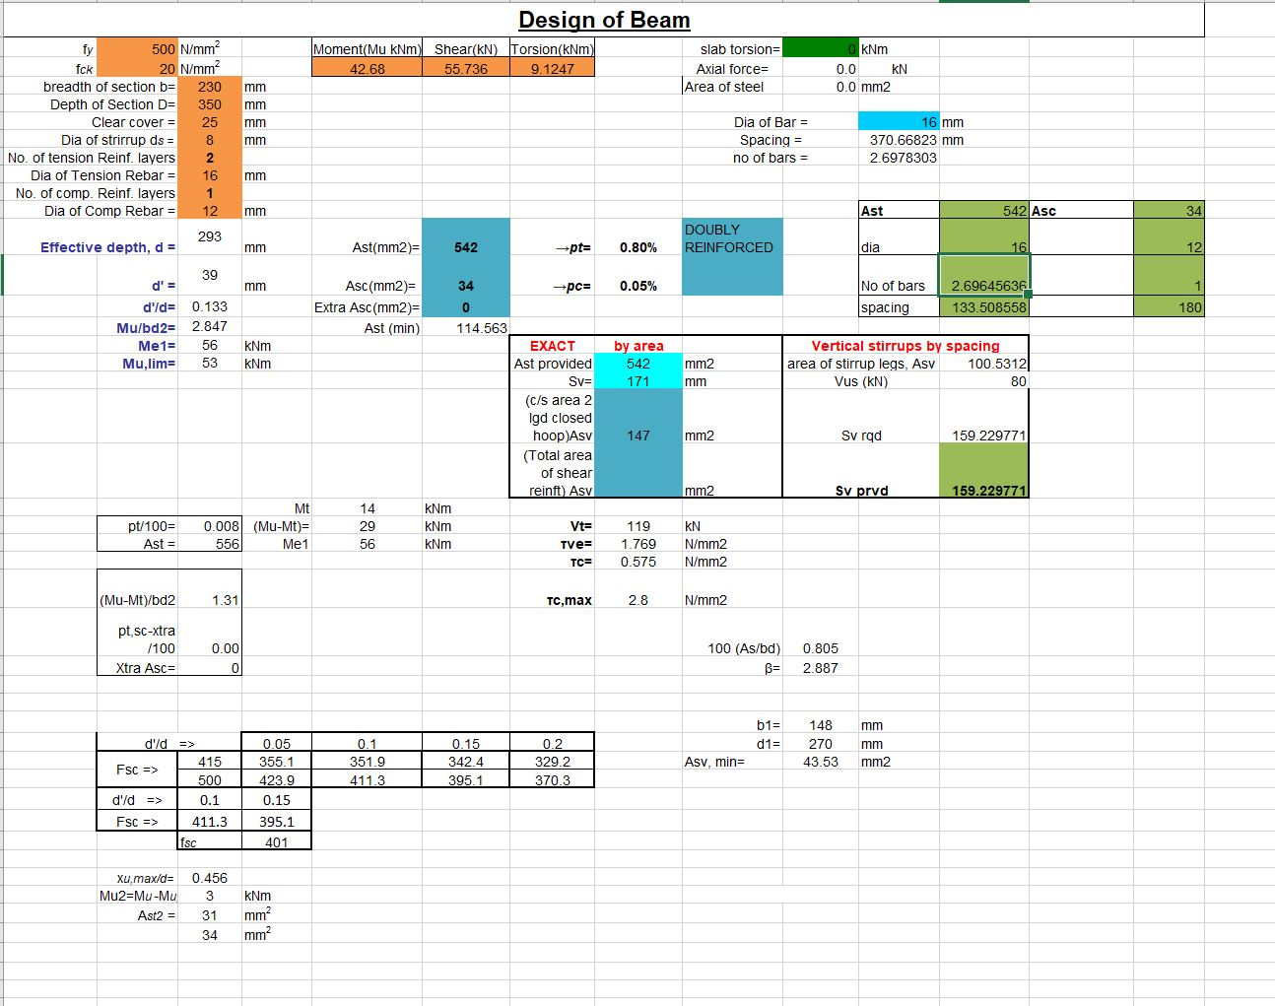

For Bottom Bar
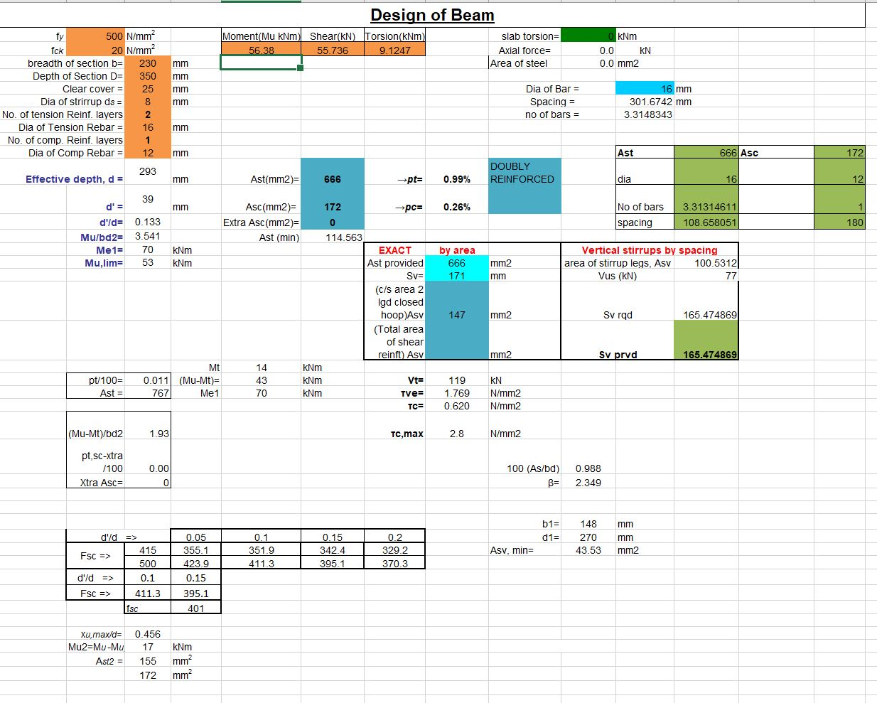

CONCLUSIONS AND RECOMMENDATION
Residential building with simple configuration has been fully designed using a computer program, ETABSv18. All the required design details of slab, beam, column and footing and staircase have been presented. Possible best-approaches have been adopted for most-economical design yet fulfilling all the requirements for important building. Due considerations have been given to the probable increase in load and strength as a partial factor of safety. Also, double tie-beams, on regular tie-beam at plinth level and one at top level of footing-pad is specified as the building is being constructed in high seismicity area. During construction, it is mandatory to followIS13920, regarding provision of stirrups and ties, development lengths, splices and other detailing. Band at sill and lintel are provided to increase lateral strength of wall and to improve opening weakness on wall. Strict Control over quality of materials and workmanship is required for expected performance of building in future. Hence, following shall be considered during construction works to obtain expected results.
A. General:
a. All works to be carried out in accordance with current best practice, Building Regulations, the project specification and relevant Nepal Building Code (NBC), Indian Standards and Codes of Practice. Materials and components to be appropriate for their intended use.
b. The construction-works shall only be carried-out by trained mason with supervision of Engineer.
c. During construction, the contractor shall be responsible for maintaining the structure in a stable condition and ensuring no part shall be damaged under construction activities.
d. Workmanship and materials are to be in accordance with the relevant current Standards including all amendments and the local statutory authorities, except where varied by the contract document.
e. All coarse aggregate used shall be crushed stone aggregate. The nominal size of coarse-aggregate for RC bands and splints shall not exceed 12.5mm.
f. Clean sand, with minimum silt and free from clay and organic materials shall be used.
g. Ordinary Portland cement conforming to IS 269:1976 shall be used for all cement works.
h. At least 48 hours’ notice shall be provided for all engineering inspections.
B. Structural:
1. Cast-In-Situ concrete/micro-concrete shall have minimum 28 days’ compressive cube strength of 20N/mm² for all structural members unless otherwise stated.
2. The concrete compressive strength shall be measured on 150*150*150mm cube at 28 days, for various structural elements.
3. Reinforcing steel shall be, TMT rebar with ultimate strain not less than 14.5% can also be used.
4. Cover to main reinforcing steel be in accordance with IS 456:1978 & as specified in the structural drawings.
5. Clear Cover of Concrete shall not be less than that given below:
a. Concrete surface at soil = 50mm
b. Concrete on PCC, Bricks, STONE, etc. = 25mm
6. Unless otherwise specified, all horizontal & vertical construction joints shall be roughened.
7. A minimum of 48 hours’ notice shall be given to the Engineer before applying plaster, concrete/microconcrete is poured, in order that the formwork and/or reinforcement may be inspected.
8. All R.C.C work shall be continuously cured for 14-days.
9. All cement plaster works shall be continuously cured for 7 days.
10. Any damage to surface during erection/construction is to be made good.

REFERENCES

a. IS code 456-2000: Plain and Reinforced Concrete code of Practice
b. IS code 1893 (part I)-2002: Criteria for earthquake Resistant Design of Structures
c. IS code 875-1987: Code of Practice for Design Loads
Part 1 Dead Loads
Part 2 Imposed Loads
Part 5 Special loads and Load combination
d. IS code 13920-1993: Ductile Detailing of RCC structures subjected to seismic force code of practice
e. Nepal National Building Code (NBC 105): Seismic Design of Buildings in Nepal
f. RCC structures by A.K. Jain
g. RCC structures by S.N. Sinha
h. Limit State Design by Vargees
i. Structural Design of Multistoried building by U.H. Varyani
j. IS code SP 16 Design guidelines for RCC Structures
k. IS code SP 34 for detailing of RCC structures

